Steps:

!)Create the data source

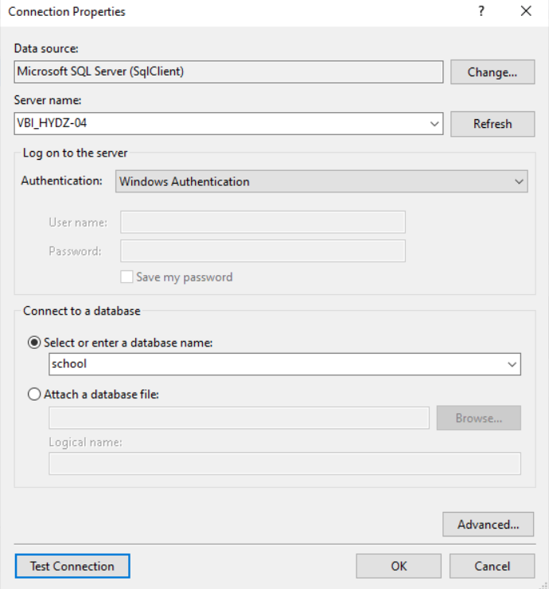

2)create data set:

Create the dataset for the first table and create the table for the first table

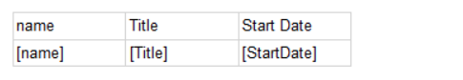

b)

create the second table with parameter which will take the input from the first table and display the its content

c)

add the new table for the second dataset next to the first table

d)

go to parameter-> select hidden from general

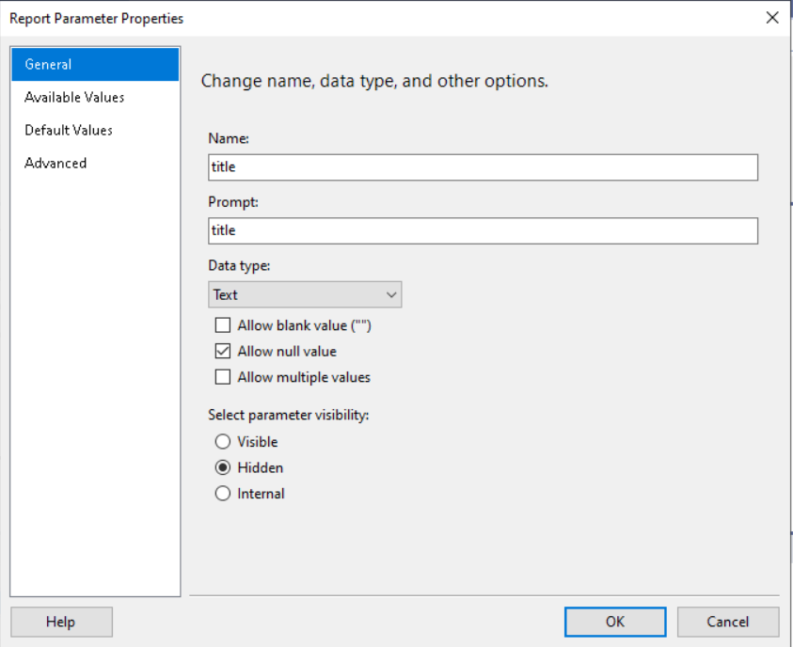

e)

select the field which will be the input for the second table

right click->text properties

action -> select the same report-> in add parameter->select parameter name and give the parameter value.

3) hide the second until the parameter set with the value:

Select table-> Tablix properties-> visibility->show or hide->give the below expression-> click expression

**Don’t give toggle for this process**

Exp:

**Iff(isnothing(parameter_field),true,false))**

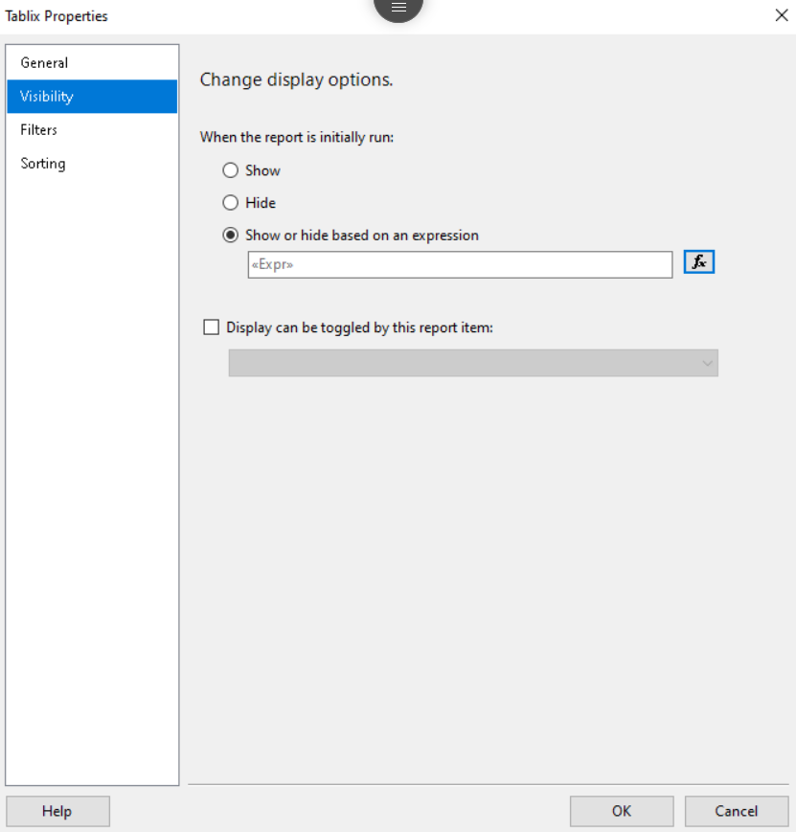

4)highlight the selected value form the first table:

Select the value field

Right click->text box properties->fill->give the given below expression

